Modular ADC Evaluation PCB
Confidential Customer Project
Designed by: [Zuheer Al hariri]
Electrical & Electronics Engineer | PCB Design (Altium Designer, Cadence)

1. Project Overview
This project involved the design of a modular PCB evaluation platform developed to support testing and characterization of a customer-designed Analog-to-Digital Converter (ADC).
The board was intended to provide a controlled, low-noise, and flexible environment for validating ADC behavior during development and integration phases.
All circuit details, specifications, and performance metrics are protected under customer ownership and confidentiality agreements. This document focuses on design methodology and engineering approach, not proprietary implementation.

2. Design Objectives
The PCB was designed to meet the following objectives:
- Enable reliable interfacing with a proprietary ADC device
- Support modular testing and subsystem isolation
- Preserve signal integrity in a mixed-signal environment
- Provide accessible test points for laboratory validation
- Allow future revisions without full redesign

3. System Architecture
The board follows a modular architecture, separating functional domains to reduce interference and simplify testing.
Typical functional partitions include:
- ADC interface and support circuitry
- Power regulation and filtering domain
- Reference and bias support
- Digital interface and control access
- External connectors for test equipment
This separation improves measurement reliability and enables independent subsystem evaluation.

4. Schematic Design Approach
The schematic design emphasizes clarity, maintainability, and testability:
- Explicit separation of analog, digital, and power domains
- Decoupling and filtering strategies appropriate for ADC evaluation
- Clearly defined net naming and hierarchical structure
- Dedicated test points to support probing and characterization
Component selection prioritized electrical performance and stability over cost, consistent with an evaluation-focused design.

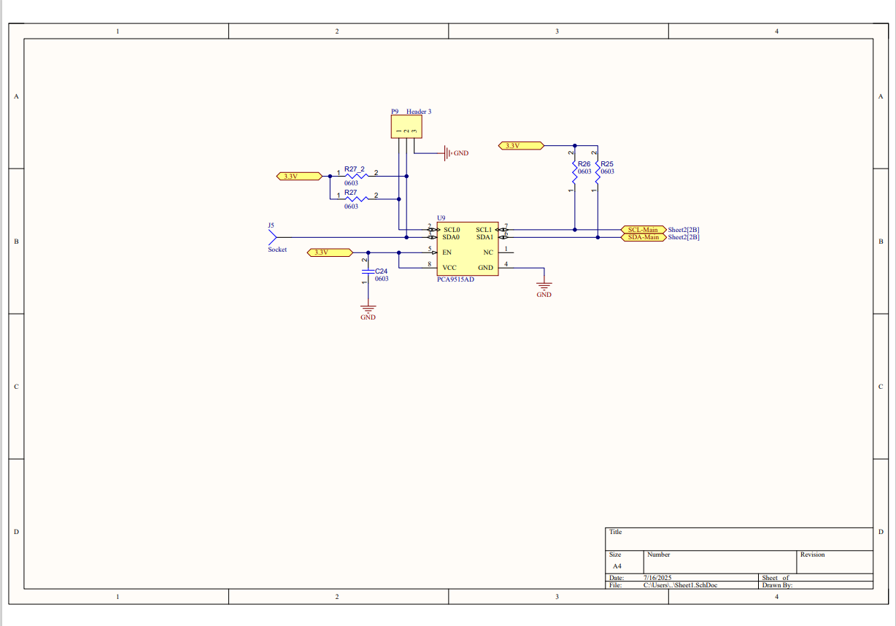
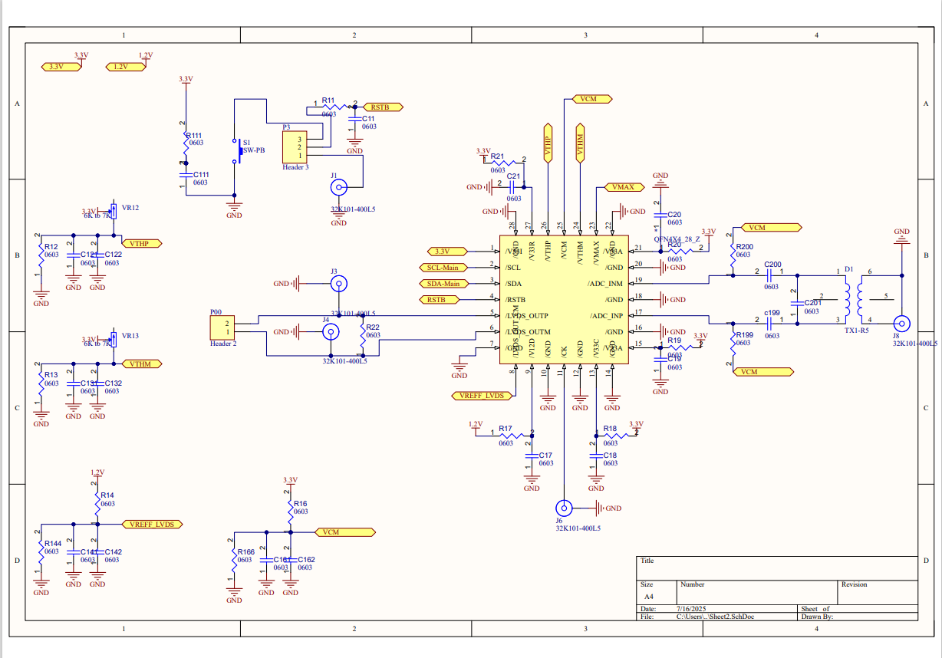
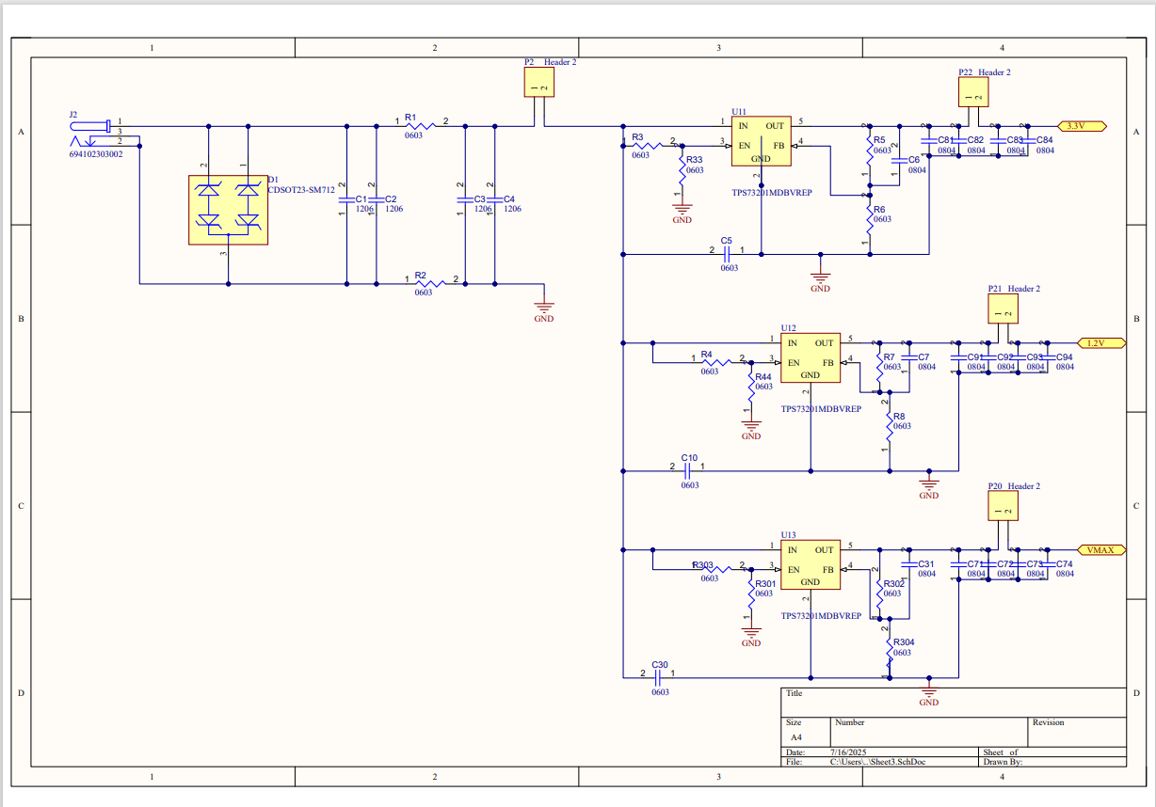

5. PCB Layout Strategy
The PCB layout was executed following best practices for mixed-signal and data-conversion systems:
- Grounding strategy designed to minimize noise coupling
- Short and direct routing for sensitive analog signals
- Close placement of decoupling capacitors
- Physical separation between analog and high-speed digital routing
- Stack-up and routing discipline selected to support signal integrity
The layout prioritizes measurement fidelity and electrical robustness rather than form-factor optimization.

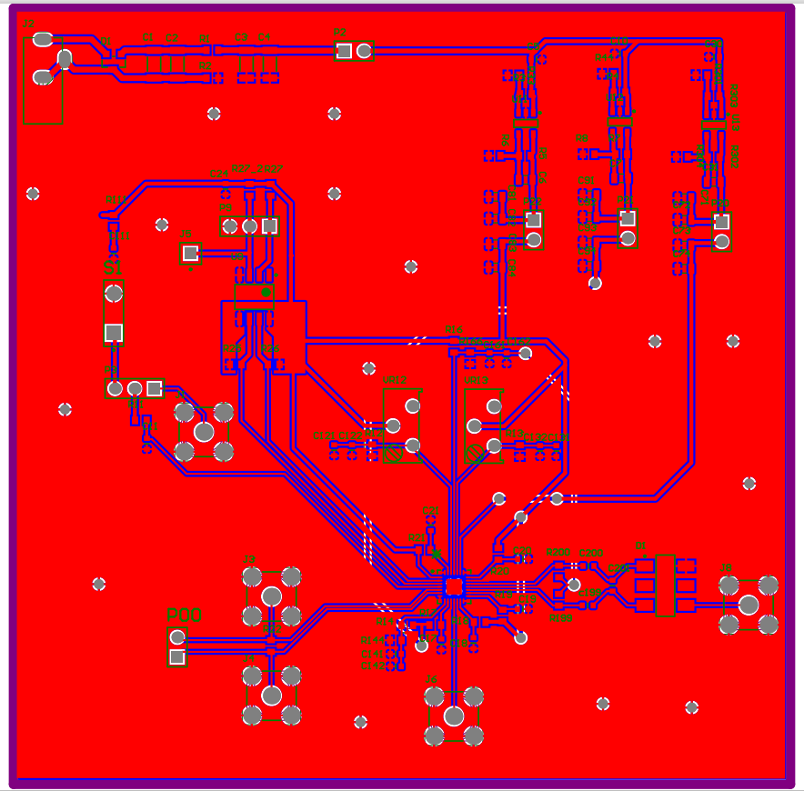

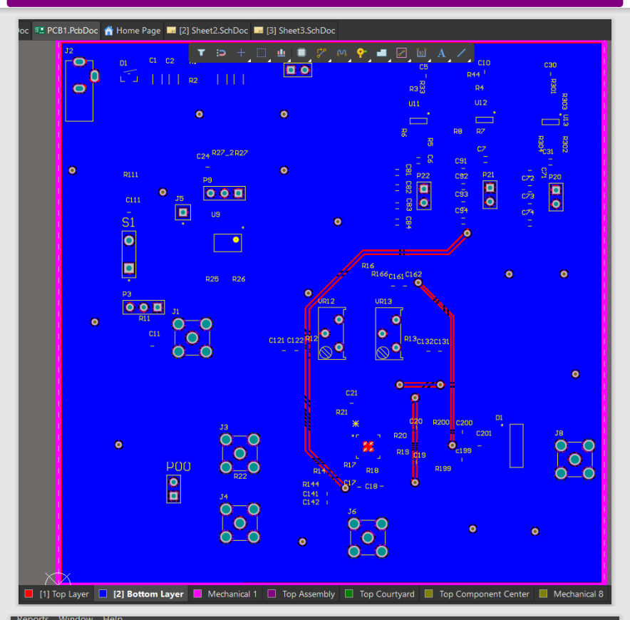

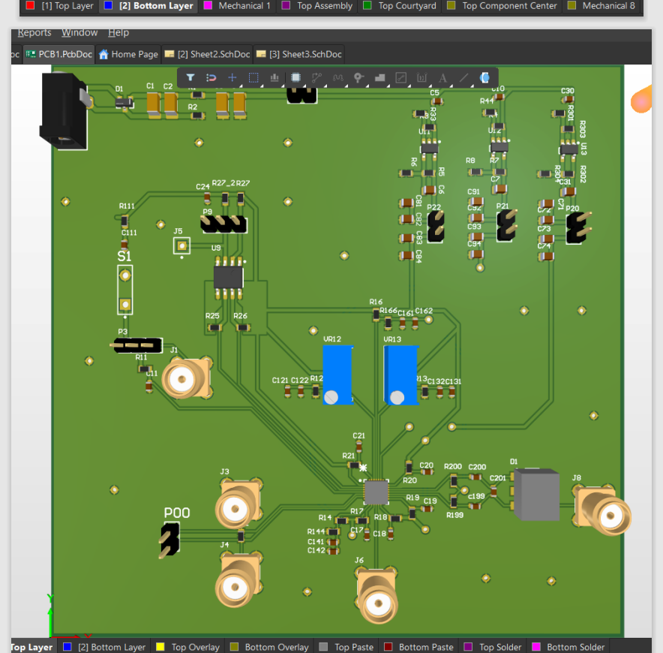

6. Test and Validation Intent
Although the PCB does not implement ADC logic itself, it was designed to support:
- Functional validation
- Electrical performance characterization
- Integration testing within a broader system
The board provides sufficient access for instrumentation and debugging while maintaining a stable electrical environment.

7. Confidentiality Notice
All schematics, layouts, and design artifacts shown are the intellectual property of the customer.
Specific component values, performance figures, and architectural details are intentionally excluded.
This portfolio entry demonstrates engineering methodology, PCB design discipline, and professional handling of customer IP.

8. Conclusion
This project demonstrates experience in:
- Professional PCB design for mixed-signal systems
- Modular architecture for evaluation platforms
- Schematic capture and layout using industry-standard EDA tools
- Working under real-world confidentiality constraints
The design reflects practical considerations encountered in semiconductor evaluation and customer-owned IP projects.

